Working in the Cloud

with ClearMedia Academy

ClearMedia vCloud Director template 1.9

**Disclaimer**:

By using the ClearMedia vCloud Director templates, you can greatly reduce the amount of time needed to deploy new VMs. These templates have been configured with the best practices in mind, to assure optimal stability and performance. Although use of the template is not compulsory, it is recommended!

On this first page you can find a small overview of the required steps. It is intended for engineers that already have experience with the ClearMedia vCloud Director and previous ClearMedia templates. The larger, more in-depth explanation with screenshots, can be found further on. It can be used by people without any prior knowledge if the overview is not clear or if it has been a while since your last deployment.

You can deploy the template from 2 different places. We use the first option in this document.

1. from the vApp Templates under the Library
2. from the vApp’s view under “Compute”

Quick steps

This guide assumes you are building a new vApp and deploying the template from the “Libraries” tab with a single server setup. Connecting the new vApp to the internet is covered in the later documents.

* Create a new, empty vApp
* Add a vAppnet network
* Add VM’s based on ClearMedia templates
* Wait for them to finish deploying
* Change VM name, resources and VM guest-customisation properties
* Start VM’s and check if all is OK
* Stop VM’s and disable all VM guest-customisation properties

In-Depth explanation and step-by-step procedures

* Ask ClearMedia for extra resources via ticket, referring to a newly created quote.
* Check if you have enough resources in the relevant Virtual Datacenters via the “Datacenters” view
* Also check if you have enough storage, per Tier, by opening up the vDC and clicking on “Storage Policies”
* Contact ClearMedia if there are not enough resources.

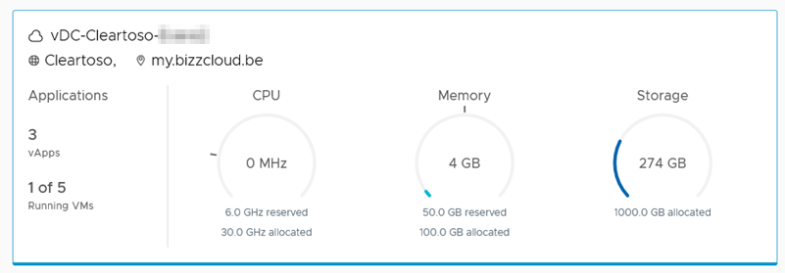

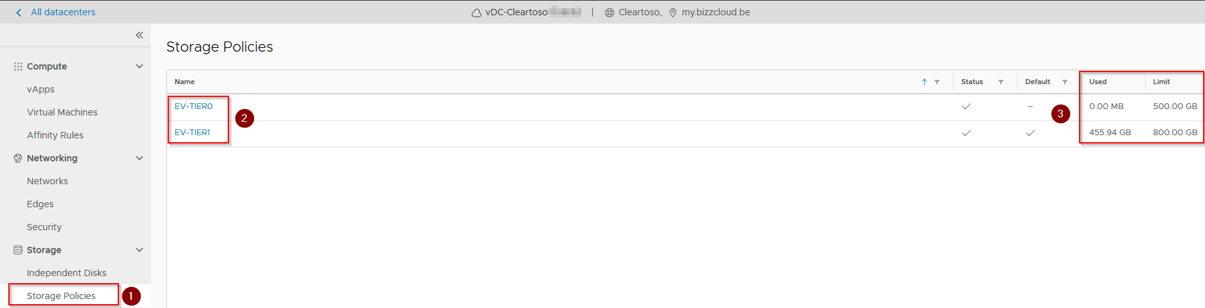

* Open the virtual datacentre where you want to build the new vApp
* Click on “vApp’s” and then on “New vApp”

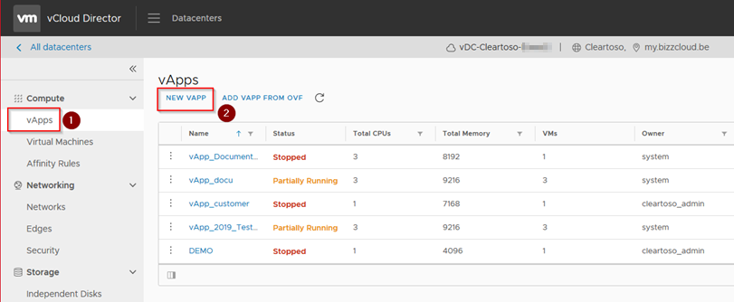

* Give the new vApp a name and skip the “Add Virtual Machine” step for now. Click “Create”

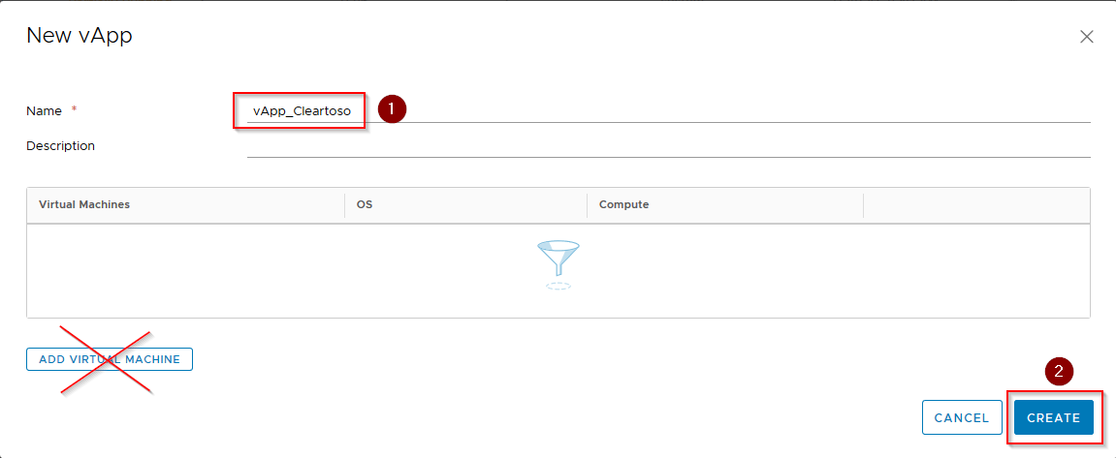

* Click on the 3 dots next to the new vApp and click on “Add Network…”

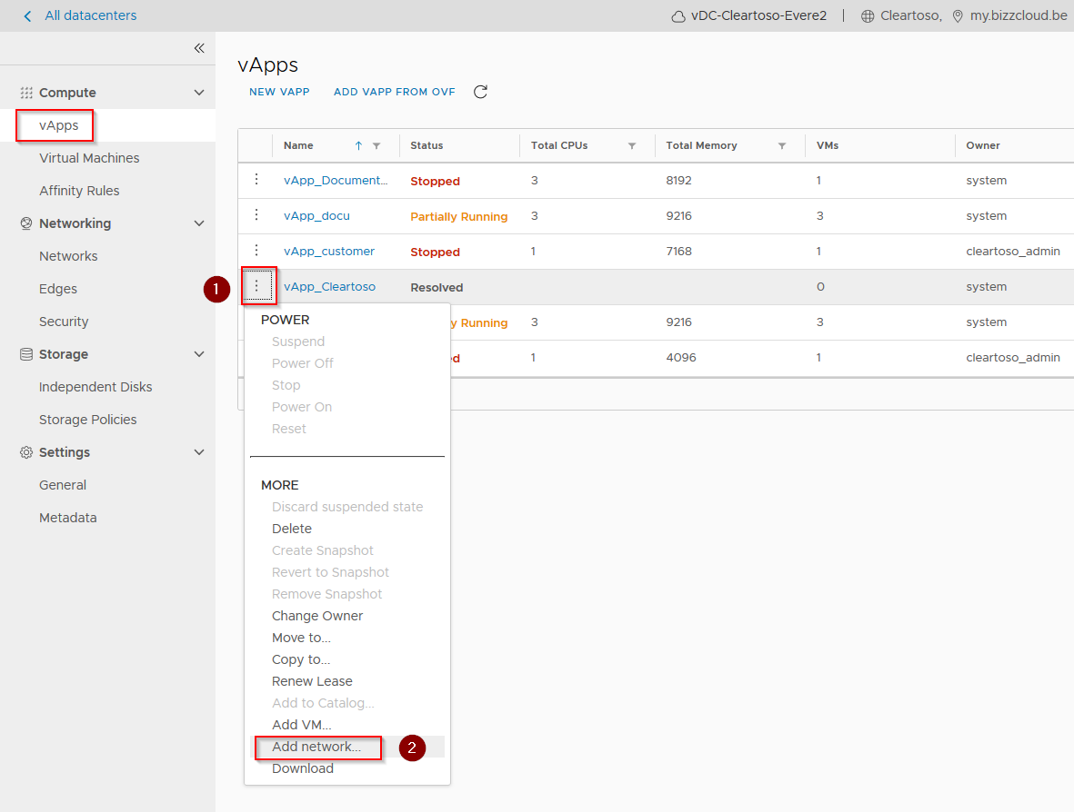

* Choose “vApp Network”, give it a name, declare Gateway IP, DNS IP’s and Static IP Pool.

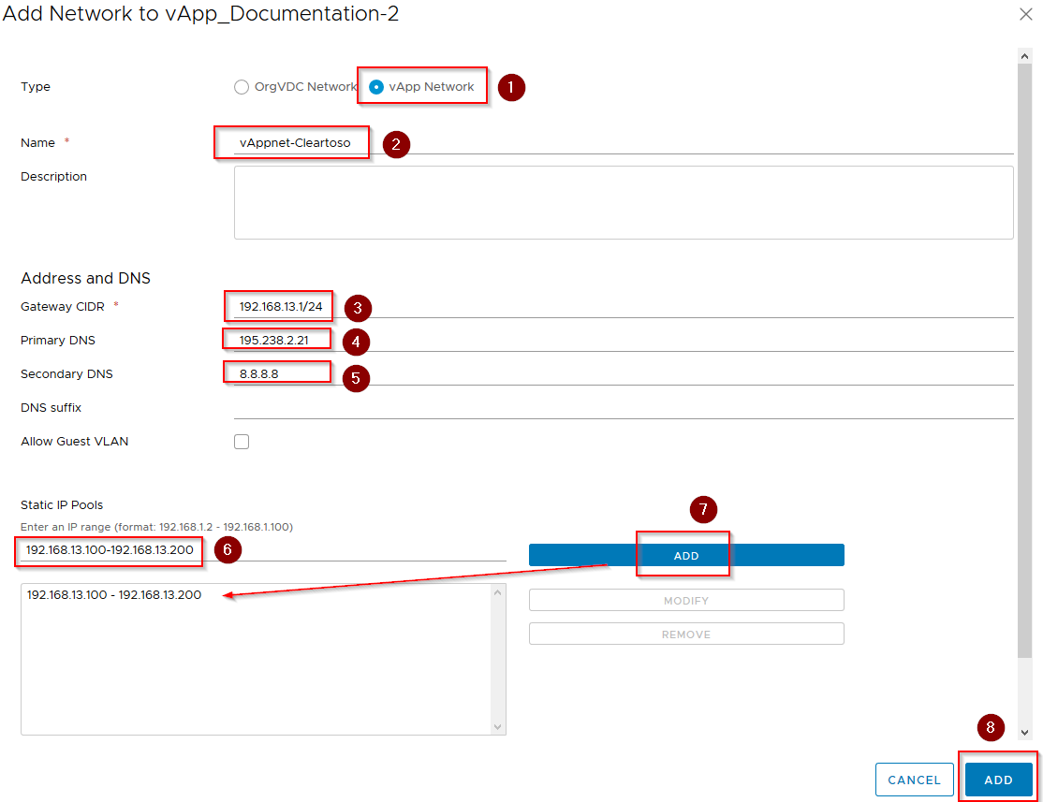

* Add VM’s by clicking on the 3 dots next to the vApp, and clicking on “Add VM…”

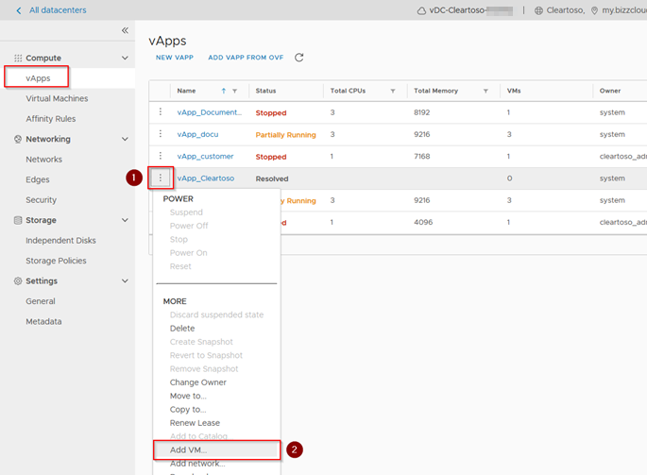

* A new Wizard appears. Click on “Add Virtual Machine”
* In the wizard, choose “From Template”, give the new VM a name, select the Win2019 Version 1.9, disable the “Power On” option and click on OK

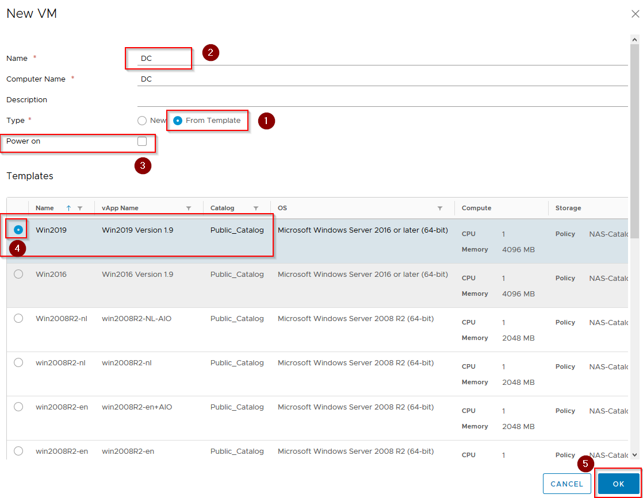

* If needed, you can repeat the steps to add extra VM’s in to the task list. For example a RDS server or FireboxV firewall. When ready, click on the “Add” button to start the deployment of the templates.

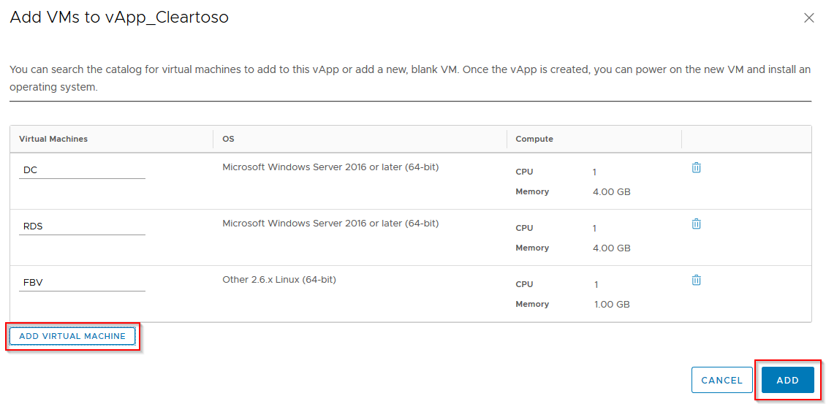

* You can close the box by clicking on the cross at the top right

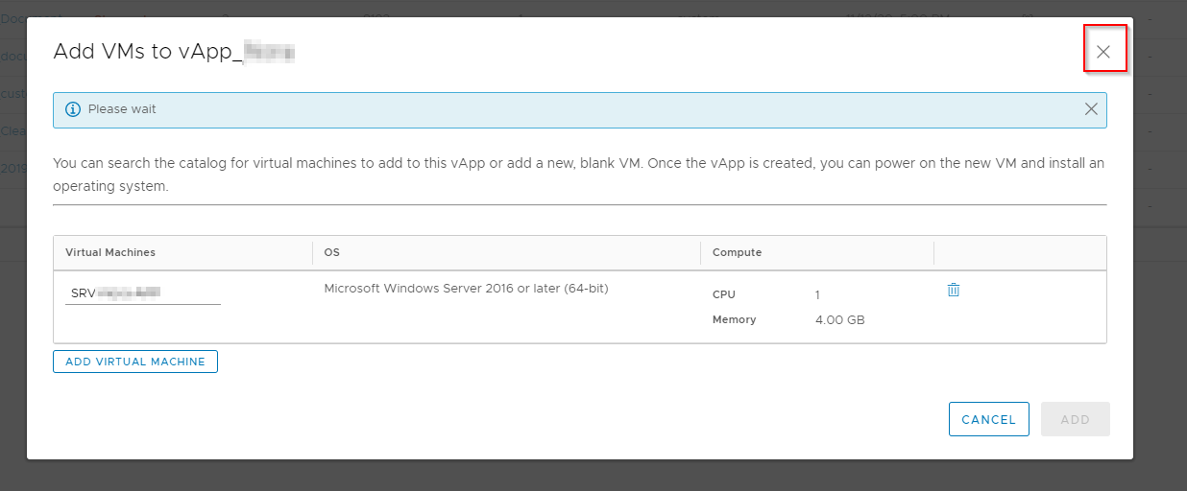

* Go back to the “vApps” tab. You can see the progress of the deployment here. It will keep showing “Unresolved”. This is normal. Please wait.

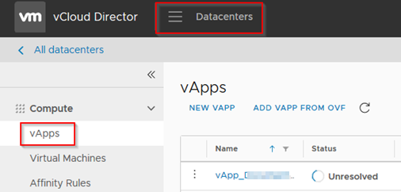

* It might take at least 20 minutes per VM to deploy.
* Afterwards check the Boot Properties of the newly created vApp by opening it and going to the section “Advanced”. Check boot order and “Stop Action” for each VM. For a Windows Server, this should be “Shut Down”, for FBV firewall appliances it should be “Power off”. Save the changes.

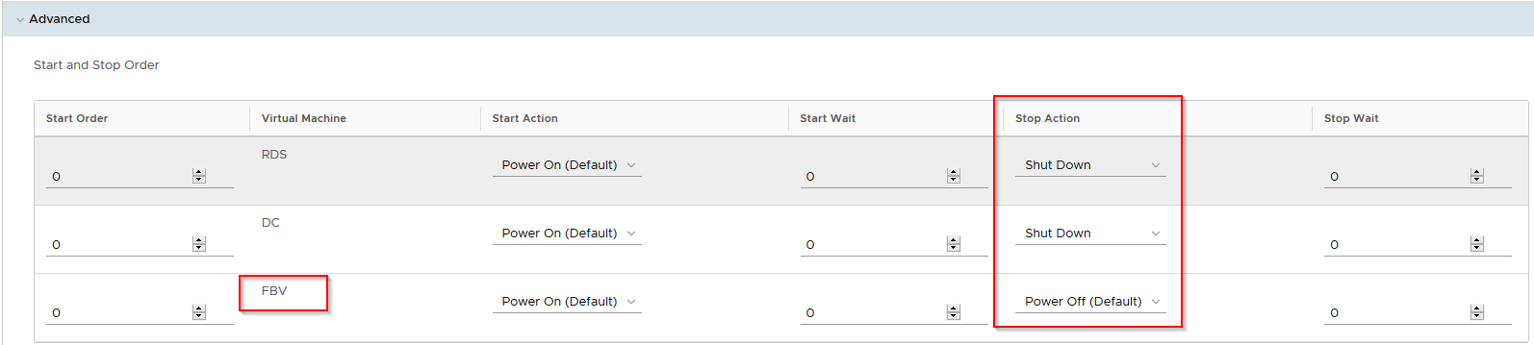

* Now edit the new VM’s.
  + On the “General” view, change the Virtual Machine name and Computer name starting with “SRV-“ and then the rest of the VM name

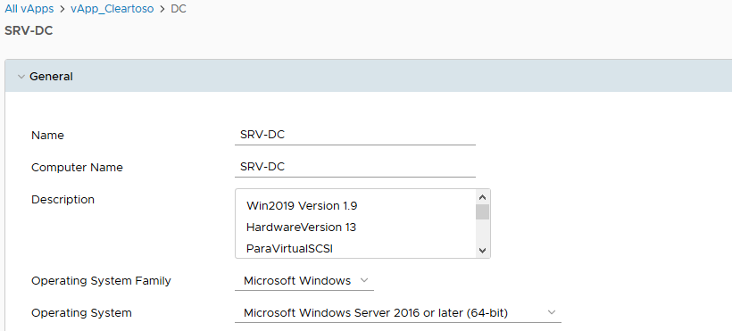

* + Under the “Hardware” view, note that the tick boxes “Virtual CPU Hot add” and “Memory Hot add” are enabled.

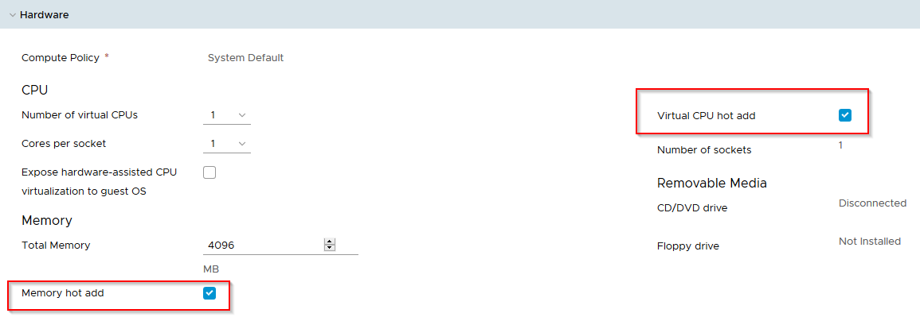

* + Here you also choose the desired resources. Type in what you need in MB’s. However, if you need more then 200GB of disk space, you must add this 200GB per hour or contact ClearMedia.

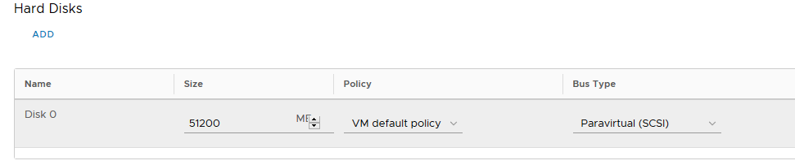

* + At the network adapters verify you are using a “VMXNET 3” adapter with Windows VM and the “Connected” box is ticked.

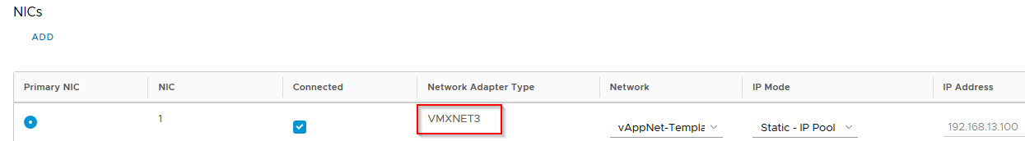

* + On the “Guest OS Customization” view, choose a complex password with a minimum 7 characters, 1 special character, and 1 number. Otherwise Windows will not accept it during boot and Guest Customisation and logging on to the system will fail.

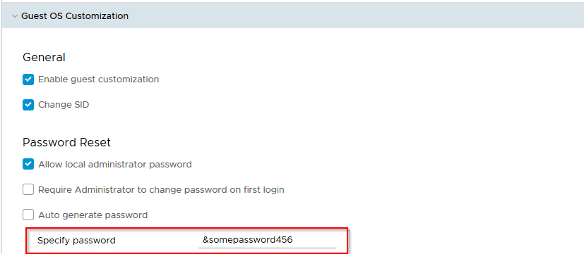

* + Click on the “Save” button below.



* Power on the VM by returning to the vApp view, clicking on the 3 dots next to the VM and pressing “Power On”. If this is the first time, wait at least 5 minutes for powering on and guest customisation to run successfully. It should finish with an automatic reboot.

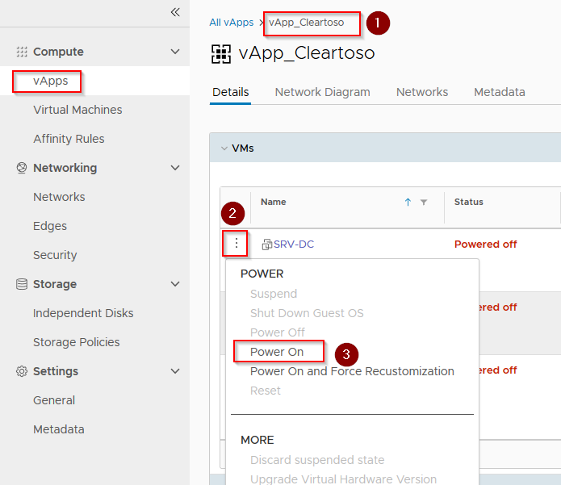

* Open the Virtual Machine console based on the “How-To VM Console” document.
* Logon with the new administrator credentials and verify that Guest Customisation ran successful.
* The VM will ask if it is allowed to be discovered on the network. This is personal preference.
* Then turn the VM off again by clicking on the same 3 dots and clicking “Shut Down Guest OS”
* Disable all Guest Customisation options, starting from the bottom. Start with the “Change SID” tick box. Finish with the “Enable Guest Customisation” box.
* Click on the “Save” button, found at the bottom.

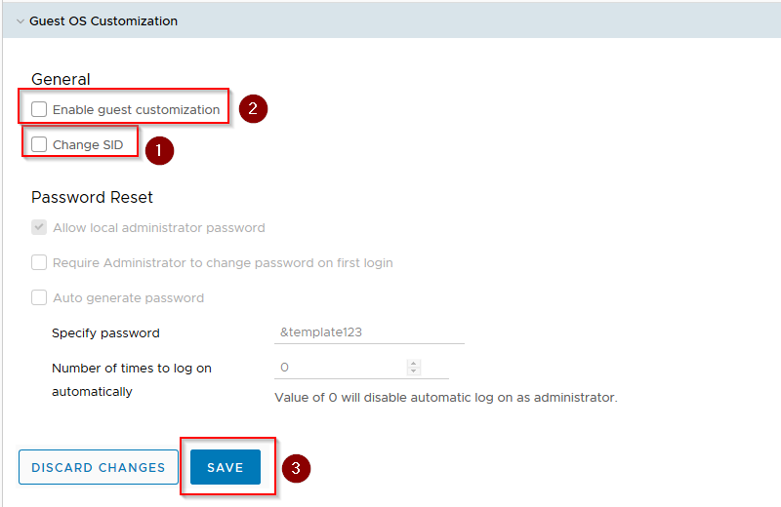

* After disabling all Guest Customisation options leave the VM off and also stop the entire vApp.
* Now add an internet connection via a vShield Edge or WatchGuard FireboxV. You can find the procedures in the next documents (How-To 2 vShield Edge & How-To 3 Watchguard FireboxV).
* **You have finished this guide!**